**What is the Main Economic Cause of Domestic Migration in the U.S.?**

We found that the highest taxed states as well as states with the highest rents are experiencing population decline. States with lower taxes are experiencing population growth, however rents are still relatively high, but not as high as higher taxed states.

This correlation however does not prove causation. They are trends to analyze and help us understand state-to-state migration. There is a case to be made that lower cost (less taxes, lower rents) can outweigh higher income levels in migration decisions. States with high taxes and rents also tend to have the highest income levels.

**Where are People in High Tax States Moving to?**

It was a common trend to see residents in high tax states move to states within the top five of domestic population growth. These movers were also often going to states with low to no state income tax.

We closely analyzed five high tax states (NY, CA, OR, DC, MN) and where their residents were moving to.

**NY** – The other two states in the tri-state area (CT, NJ) were a common relocation for New Yorkers as well as Pennsylvania (low tax – 3.07%). The tri-state trend could be related to social/family factors and job opportunities among other factors. When analyzing outmigration trends in New Jersey and Connecticut you see a lot of relocation to other tri-state area states or Pennsylvania.

**CA** – Texas, Arizona, Washington and Nevada made the top 5 of where California residents were moving. Texas, Washington and Nevada all have no state income tax. Arizona has a low state income tax rate of 4.54%. Oregon also made the top 5 list of where California residents move. This could be the job factor or social reasons. Below you will see the trend of Oregon residents moving to California in high numbers.

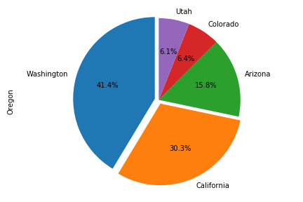**OR** – It is a common occurrence to see California and Oregon residents moving to each other’s states. Oregon residents also heavily favor their neighboring no tax state Washington as well as other low tax Western states: Arizona, Colorado and Utah.

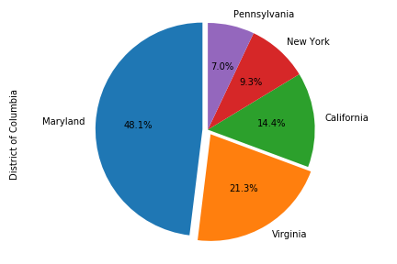**DC** – The most common states people in DC moved to were Maryland and Virginia which border the City of Washington D.C. with lower state income tax. DC has its own rate of 8.95% with Virginia and Maryland having rates of 5.75%. This could be due to employment in DC and settling in the suburban outskirts or other social reasons. Pennsylvania, New York and California all cracked the top 5 which could be due largely to employment factors given they are also large high-income markets with highly developed industries and economies.

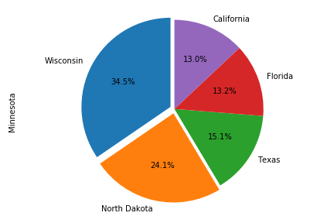**MN** – Neighboring mid-western states Wisconsin and North Dakota were popular relocations for Minnesota residents. North Dakota has a state income tax rate of 2.90% which is very low. Minnesota residents also favored two non-tax states, Florida and Texas.

**Does Low and No State Income Tax Affect Domestic Migration in the U.S.?**

Yes, however correlation does not prove causation. Even though high taxes correlate with outmigration it does not prove that the former caused the latter. In this graph there is a slight downward sloping trendline. You could infer from this trendline that higher state income taxes correlate to higher outmigration.

**How do Median State Employment Earnings Affect Domestic Migration?**

They do not. It is counterintuitive to think that high income and outmigration correlate. A better metric to analyze correlation would be inmigration and job opportunities/job growth. The graph does tell us the truth. People are leaving high tax and high rent states, however these states also have the highest median household incomes.

**Does Rent Affect Domestic**

**Migration in the U.S.?**

Yes, however this relationship does not prove causation. Residents of high rent states are often migrating to states with lower rents (albeit still on the higher end). States that have the highest rents also have the most population decline. This trendline shows outmigration increasing with higher rents with a steeper downward slope than our other two scatter plots.